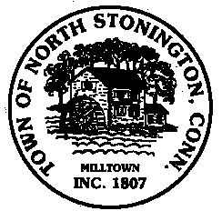
Town of North Stonington
Board of Selectmen Special Meeting
New Town Hall Conference Room
February 2, 2018
1:00 PM

MINUTES

- Call to Order/ Roll Call
First Selectman Urgo called the meeting to order at 1:00 pm with Selectmen Carlson and Kincaid present.
- Route 49 Bridge Repairs
A group of ConnDOT representatives as well as Jeff Fontaine from Close, Jensen, and Miller attended the meeting to review the proposed bridge replacement with the new Board of Selectmen.
The timeframe for completion was discussed along with traffic closure strategy, hours of work, design and completion projections. It was stressed that the project will take eight weeks. Though May 2018 had been the planned start date for the project, it was noted that next year was now more likely.
- Tax Relief Programs
The Selectmen had a brief discussion on Tax Relief Programs that are already in use in North Stonington and the State in general. The Board decided that their near-term focus should be determining the fiscal 2018/2019 budget before further research on such programs is undertaken.

