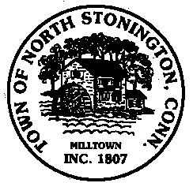 Town of North Stonington
Board of Selectmen Meeting
New Town Hall Conference Room
July 11, 2017
7:00 PM
MINUTES

- Call to Order/ Roll Call-Meeting was called to order by First Selectman Murphy
at 7:02 PM with Selectmen Mullane and Donahue present.
2. Pledge of Allegiance
3. Minutes-A motion was made by Selectman Donahue and seconded by
Selectman Murphy to approve the minutes of June 27, 2017, carrying. 3-0
4. Correspondence
5. School Modernization Project Updates
Budget Status of Initial $1.59 M Authorized-General Discussion no action
Commissioning Services RFP-After a review of the RFP the Selectmen agreed to advertise for the Services with bids due back July 21, 2017.
6. WPCA Ordinance Amendment-General review of amendment proposed; it was
decided that the amendment will be placed on next town meeting.
7. Chester Maine Bridle Trail Update-Review of Planning and Zoning
recommendations under CGS 8-24 and attorney’s comments. Still pending the
Homeowners’ Association agreement.
8. Public Comments and Questions
9. Adjournment-7:30 PM

