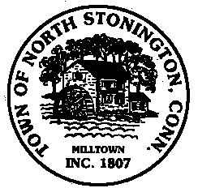 Town of North Stonington
Board of Selectmen Meeting
North Stonington Senior Center
July 25, 2017
7:00 PM
MINUTES

- Call to Order/ Roll Call-First Selectman Murphy called the meeting to order at
7:04 PM with Selectmen Mullane and Donahue present.
2. Pledge of Allegiance
3. School Modernization Project
$1.59M Budget Update
Commissioning Services Award-A motion was made by Selectman Donahue
and seconded by Selectman Murphy to accept the recommendation of the
School Modernization Committee to award Horizon Engineering Associates LLP for pre-construction support
In the amount of $10,100, carrying 3-0
Schedule/Future Bond Anticipation Notes
4. Hyde Mill Pent way Cottage – General Discussion
5. Northern Town Boundary-Selectman Mullane will get quotes on the cost of a
survey and meet with the other towns on acceptance and filings
6. Project Updates-First Selectman Murphy gave reports on the Village Waterline
Extension project, Remodeling of the Land Use Offices, start of the Center for
Emergency Services, Recreation
Building bathrooms are now open to the Public, Route 49/184 Pocket Park
permits are in place and the Town has received a $1,200 for Chelsea Groton
Bank, chipsealing is scheduled to begin on or about August 1st.
7. Minutes-A motion was made by Selectman Donahue and seconded by
Selectman Murphy to approve the July 11, 2017, carrying 3-0
8. Correspondence
9. Public Comments and Questions
10. Adjournment-9:08 PM

