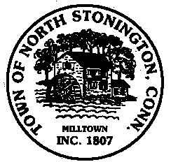 Town of North Stonington
Board of Selectmen Meeting
New Town Hall Conference Room
September 12, 2017
7:00 PM
MINUTES

- Call to Order/ Roll Call-First Selectman Murphy called the meeting to order at
7:00 PM with Selectmen Donahue and Mullane present
2. Pledge of Allegiance
3. PUBLIC HEARING- Ledge Light Health Director Stephen Mansfield-
made a presentation of the services and benefits of joining a health district.
First Selectman Murphy reminded the Board that we have been unable to fill a
key sanitarian position. Mr. Mansfield answered any questions, and First
Selectman Murphy reminded everyone that the Health District question will be
on the Special Town Meeting agenda on the 18th.
4. School Modernization Project – Borrowing-General Discussion of current
outstanding BAN and best action for the future borrowing.
5. FY 17-18 Town and State Budget Discussion-Pending State budget action and
Board of Finance meeting tomorrow evening.
6. Minutes-A motion was made by Selectman Donahue and seconded by First
Selectman Murphy to approve the minutes of August 22, 2017, carrying. 3-0
A motion was made by Selectman Donahue and seconded by First
Selectman Murphy to approve the minutes of September 6, 2017,
carrying. 3-0
7. Correspondence
8. Public Comments and Questions
9. Adjournment-8:45 PM

