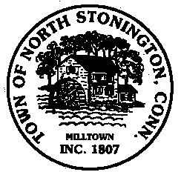 Town of North Stonington
Board of Selectmen Special Meeting
New Town Hall Conference Room
September 6, 2017
7:00 PM
MINUTES

- Call to Order/ Roll Call-First Selectman Murphy called the meeting to order at
7:02 PM with Selectman Mullane and Donahue present.
2. Pledge of Allegiance
3. Call for a Special Town Meeting September 18, 2017
Health District-Discussed both the Ledge Light Health District and Uncas
Health District. Town is having difficulty maintaining staff and training.
Water Pollution Control Authority Ordinance Amendment
Chester Maine Bridle Trails
Greene Gables Abatement and Demolition
4. Referendum Discussion –After general discussion First Selectman Murphy
Made a motion to approve a call for the special town meeting to be held on
September 18, 2017, to include the Ledge Light Health District and to send the
Chester Maine Bridle Trails and Greene Gables questions to a referendum on
October 2, 2017, from 12:00 noon to 8:00 PM, seconded by Selectman
Donahue, carrying. 3-0
5. Capital Fund Transfer Request-A motion was made by Selectman Mullane and
seconded by Selectman Donahue to request a transfer of $13,855.87
from Capital Recreation Area Lighting to Capital Town Building Improvements,
carrying. 3-0
6. Town owned stonewall discussion-First Selectman Murphy informed the Board
that stonewalls had been moved from 20 Boombridge Road and land
regraded. First Selectman Murphy is working with Land Use Office to resolve
the issue
7. Public Comments and Questions
8. Adjournment-8:22 PM

