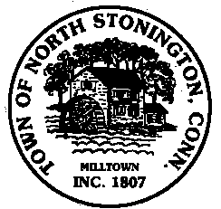
Town of North Stonington
Board of Selectmen
Special Meeting
New Town Hall Conference Room
October 16, 2018
5:00 PM

AGENDA

Call to Order
Pledge of Allegiance
Public Comments and Questions
- Appointments
- Site Restoration and Final Grading RFP Award
- October 22, 2018 Town Meeting
- Future Meeting Dates - 2019
- Survey Discussion
Public Comments and Questions
Adjournment

Public Comments limited to 2 minutes on Agenda Items Only

