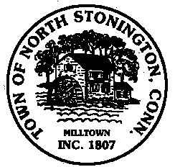 Town of North Stonington
Board of Selectmen Meeting
North Stonington New Town Hall
August 14, 2018
7:00 PM

The Regular Meeting of the North Stonington Board of Selectmen has been cancelled due to the Connecticut State Primaries.

