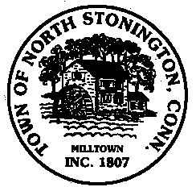 Town of North Stonington
Board of Selectmen Special Meeting
New Town Hall Conference Room
February 2, 2018
1:00 PM

AGENDA

1. Call to Order/ Roll Call
2. Route 49 Bridge Repairs
3. Tax Relief Programs
4. Public Comments
5. Adjournment

There will be a 2 minute limit on Public Comments pertaining to
Agenda Items Only

