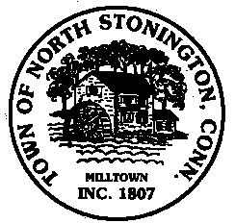 Town of North Stonington
Board of Selectmen Special Workshop
Wheeler High School Media Center
August 14, 2018
5:00 PM

AGENDA

1. Call to Order/ Roll Call
2. Pledge of Allegiance
3. Discussion of town owned and leased properties
4. Adjournment

There will be a 2 minute limit on Public Comments pertaining to
Agenda Items Only

