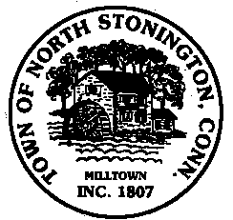
Town of North Stonington
Board of Selectmen Meeting
North Stonington New Town Hall Conference Room
October 9, 2018
7:00 PM

AGENDA

Call to Order
Pledge of Allegiance
Public Comments and Questions
- PAYT-Pay As You Throw Presentation
- Vacancy/Staffing
- Tax Collector’s Appointment and Office Hours
- Treasurer’s Position/ Pending Vacancy discussion and/or appointment
- Conservation Commission appointment
- Holly Green Condominium Sale
- Center for Emergency Services Storage
- Greene Gables Update
- Call of a Special Town Meeting-October 22, 2018
Minutes
Public Comments and Questions
Adjournment

Public Comments limited to 2 minutes on Agenda Items Only

