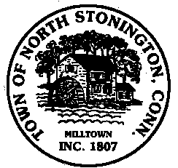
Town of North Stonington
Board of Selectmen Meeting
North Stonington New Town Hall Conference Room
November 13, 2018
7:00 PM

AGENDA

Call to Order
Pledge of Allegiance
Public Comments and Questions
- CES Committee-Discussion of 3 Bay Garage
- North Stonington approved Solar Project-Ella Wheeler Road
- Strategic Planning Discussion
- 74 Swantown Hill Road
- Little League-Equipment Purchase
- EMPG-Civil Preparedness Resolution
- Building Official position
- Art & Cultural Event
- Maple Syrup Harvesting-Main Street property
- Tax Refunds
- Annual Meeting Schedule for 2019
Minutes-October 24, 2018
Public Comments and Questions
Adjournment

Public Comments limited to 2 minutes on Agenda Items Only

