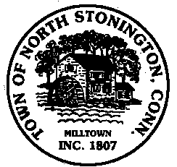
Town of North Stonington
SPECIAL
Board of Selectmen Meeting
North Stonington New Town Hall Conference Room
October 24, 2018
7:00 PM

AGENDA

Call to Order
Pledge of Allegiance
Public Comments and Questions
- Center for Emergency Services Storage
- Town Treasurer/Special Election-Set Date
- Appointments
- Greene Gables Update
- OpenGov
- Clarks Falls Property Advertisement—FOR SALE
- Capital Improvement Funding Ordinance
- Discussion of Suggested Meeting Standards and Expectations
- Future Town Meeting and Budget Discussion
Minutes-October 9 and 16, 2018
Public Comments and Questions
Adjournment

Public Comments limited to 2 minutes on Agenda Items Only

