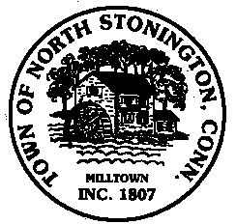 Town of North Stonington
Board of Selectmen Special Meeting
New Town Hall Conference Room
November 14, 2017
6:00 PM

AGENDA

1. Call to Order/ Roll Call
2. Executive Session with Attorney Don Baur, Perkins Coie, Washington,
DC –Review and Update on pending litigation
3. Adjournment

