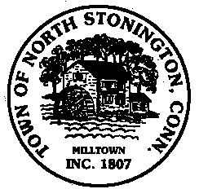 Town of North Stonington
Board of Selectmen Meeting
New Town Hall Conference Room
June 13, 2017
7:00 PM

AGENDA

1. Call to Order/ Roll Call
2. Pledge of Allegiance
3. Pawcatuck River Solar Proposal Ella Wheeler Road
Executive Session-Review of PILOT Payments
Possible Approval of PILOT Resolution
4. Village Sidewalk Committee
5. FY 2018 Budget and Mill Rate
6. Plan of Conservation and Development Action Plan
7. Minutes
8. Tax Refunds
9. Public Comments and Questions
10. Adjournment

