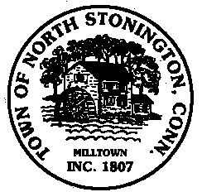 Town of North Stonington
Board of Selectmen Meeting
New Town Hall Conference Room
July 11, 2017
7:00 PM

AGENDA

1. Call to Order/ Roll Call
2. Pledge of Allegiance
3. Minutes
4. Correspondence
5. School Modernization Project Updates
Budget Status of Initial $1.59 M Authorized
Commissioning Services RFP
6. WPCA Ordinance Amendment
7. Chester Maine Bridle Trail Update
8. Public Comments and Questions
9. Adjournment

