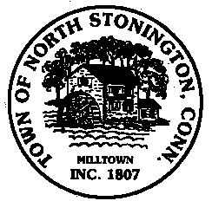 Town of North Stonington
Board of Selectmen Meeting
New Town Hall Conference Room
December 12, 2017
7:00 PM
AGENDA

1. Call to Order/ Roll Call
2. Pledge of Allegiance
3. Sewer Study Update Presentation-Mark Lancor-Dymar and CERC
4. Selectmen Weekly Meeting and Activity Updates
5. Hewitt Farm Committee Reappointments
6. Department of Emergency Management and Homeland Security Resolution
7. Communications Committee Appointments and/or Discussion
8. Capital Improvements Committee Discussion
9. Board of Selectmen-Possible Name Changes Discussion
10. Tax Relief Program Discussion
11. Administration and Finance Position
12. Correspondence
13. Public Comments and Questions
14. Adjournment

