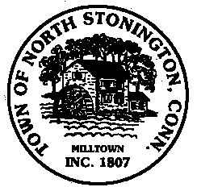 Town of North Stonington
Board of Selectmen Special Meeting
Wheeler High School Media Center
February 14, 2018
7:00 PM

AGENDA-Joint meeting with the Board of Finance

Call to Order/ Roll Call
Pledge of Allegiance
Public Comments
- Open.gov Update
- Budget Preparation 2018-2019 – Revenue Assessment
- Center for Emergency Services-Update, Financing
Public Comments
Adjournment
Call to Order- Special Board of Selectmen
- Conveyance fee for Conservation Commission
- Wintechog Hill property-Feasibility Study and 501c3 process
- Tax Refunds
- USDA Loan Resolutions Affirmation
Correspondence
Minutes
Public Comments and Questions
Adjournment

