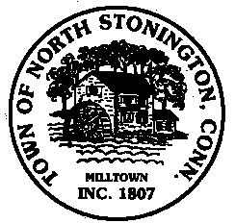 Town of North Stonington
Board of Selectmen Special Meeting
North Stonington New Town Hall Conference Room
May 22, 2018
6:00 PM

AGENDA
Call to Order
Pledge of Allegiance
Public Comments and Questions

- Executive Session-Personnel Matters & Contracts
- 284 Providence New London Turnpike-Blighted Property
- Green Gables demolition update
- Sale/Donation of SCBA units for NSVFC
- North Stonington Annual Memorial Day Parade
- Appointments
- A Civil Preparedness Advisory Council-Discussion
- Juvenile Review Board Appointments
- Communications Committee Appointments
- Hewitt Farm Committee Appointments
- Fiscal Year 2018-2019 update
- Town Organizational Chart
- Town Meeting Review
- Tax Refunds

Public Comments and Questions
Adjournment

Public Comments limited to 2 minutes on Agenda Items Only

