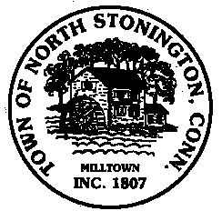 Town of North Stonington
Board of Selectmen Special Meeting
North Stonington New Town Hall Conference Room
June 19, 2018
6:00 PM

AGENDA
Call to Order
Executive Session
Contracts and Staffing
Pledge of Allegiance
Public Comments and Questions
- 284 Providence New London Turnpike-Blighted Property
- RFQ for On-Call Waste Water Consulting and Engineering Services
- Town Projects Update
- Green Gables demolition update
- Center for Emergency Services Update
- “Old Fire Station”/Rec Center Update
- School Modernization Project Update
- Fiscal Year 2018-2019 Priorities Discussion
- Civil Preparedness Committee
Gary Baron, Don Hill, Charlie Steinhart, Ryan Burdick, Jim Russell, Dave Abely, Christine Dias, Mike Urgo, and Nick Bolt
- Tax Refunds
- Transfer Requests
- Recreation Commission Appointment
Minutes
Public Comments and Questions
Adjournment

Public Comments limited to 2 minutes on Agenda Items Only

