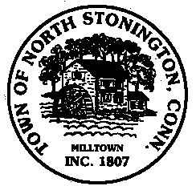 Town of North Stonington
Board of Selectmen Meeting
North Stonington Senior Center
July 25, 2017
7:00 PM

AGENDA

1. Call to Order/ Roll Call
2. Pledge of Allegiance
3. School Modernization Project
$1.59M Budget Update
Commissioning Services Award
Schedule/Future Bond Anticipation Notes
4. Hyde Mill Pent way Cottage
5. Northern Town Boundary
6. Project Updates
7. Minutes
8. Correspondence
9. Public Comments and Questions
10. Adjournment

