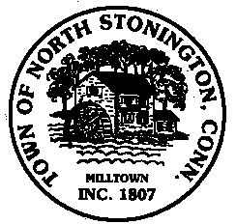 Town of North Stonington
Board of Selectmen Meeting
North Stonington Senior Center
August 8, 2017
7:00 PM

AGENDA-Cancelled

1. Call to Order/ Roll Call
2. Pledge of Allegiance
3. School Modernization Project
4. Center for Emergency Services
5. Northern Town Boundary
6. Project Updates
7. Minutes
8. Correspondence
9. Tax Refunds
10. Public Comments and Questions
11. Adjournment

