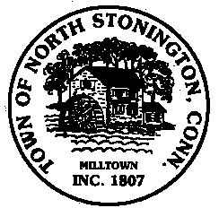 Town of North Stonington
Board of Selectmen Meeting
New Town Hall Conference Room
August 22, 2017
7:00 PM
AGENDA

1. Call to Order/ Roll Call
2. Pledge of Allegiance
3. Northern Town Boundary-Don Aubrey, PE
4. School Modernization Project Update
5. Center for Emergency Services Update
6. Pawcatuck Solar Resolution
7. Future Special Town Meeting Items
Greene Gables
WPCA Ordinance Amendments
Chester Maine Bridle Trails
8. Building Official Position
9. Public Health
Sanitarian-Well and Septic
Health District Review
10. Board of Finance Transfer Requests
Year End Transfers for Fiscal Year 2017
Recreation Lighting to Town Building Improvements
11. Town / State Budget Discussion
12. Minutes
13. Correspondence
14. Tax Refunds
15. Public Comments and Questions
16. Adjournment

