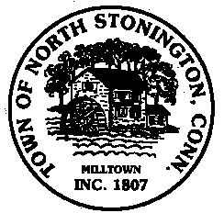 Town of North Stonington
Board of Selectmen Meeting
New Town Hall Conference Room
October 24, 2017
7:00 PM

AGENDA

1. Call to Order/ Roll Call
2. Pledge of Allegiance
3. Conservation Commission appointment
4. 586G Lantern Hill Road
Tax Abatement
Resolution
5. FY 17-18 Town –Consider and approve a call for the Annual Town/Budget Meeting and Referendum
6. Project Updates
7. Tax Refunds
8. Minutes
9. Correspondence
10. Public Comments and Questions
11. Adjournment

