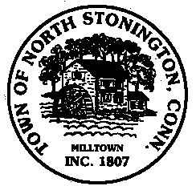 Town of North Stonington
Board of Selectmen Meeting
New Town Hall Conference Room
November 14, 2017
7:00 PM

AGENDA

1. Call to Order/ Roll Call
2. Pledge of Allegiance
3. Commission appointments-
Conservation Commission
Zoning Board of Appeals
Water Pollution Control Authority-Carl Johnston
School Modernization Committee-Sam Cherenzia
4. Peter Gruftstedt-Swantown Hill Road Little League Fields
5. Board of Selectmen Turn-over Items
6. Tax Refunds
7. Minutes
8. Correspondence
9. Public Comments and Questions
10. Adjournment

