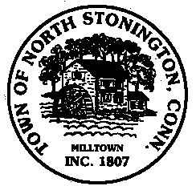 Town of North Stonington
Board of Selectmen Meeting
New Town Hall Conference Room
November 28, 2017
6:45 PM
AGENDA

1. Call to Order/ Roll Call
2. Executive Session-Town Clerk’s Appointment
Administrator/Finance Position
3. Pledge of Allegiance
4. 2018 Meeting Schedule
5. Referendum Results
6. Appointments
Economic Development Commission-George Tattersall and Asa Palmer
Village Sidewalk Committee-DJ Noyes
Hewitt Farm Committee
7. Project Updates/Meeting Reports
School Modernization
State Department of Education Letters
State Bond Commission Meeting-11/29
Borrowing Update-January Note Sale
Center for Emergency Services
DECD meeting
Southeastern CT Council of Governments
Shared Services Workshops
8. Community Ambassadors/Communications Group
9. Correspondence
Future Strategies
10. Public Comments and Questions
11. Adjournment

