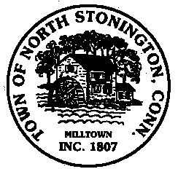 Town of North Stonington
Board of Selectmen Meeting
New Town Hall Conference Room
February 13, 2018
7:00 PM

AGENDA-Meeting is cancelled

