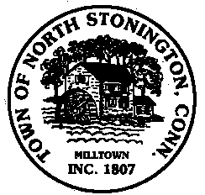 Town of North Stonington
Board of Selectmen
Special Meeting
New Town Hall Conference Room
October 2, 2018
6:00 PM

Call to Order

Pledge of Allegiance

- Discussion of Special Town Meeting – October 22, 2018
- Committee, Boards, and Commission Appointments
- Farm Preservation

Minutes
Adjournment

