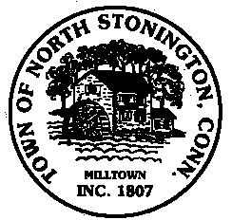 Town of North Stonington
Special Board of Selectmen Meeting
North Stonington New Town Hall Conference Room
June 1, 2018
1:00 PM

AGENDA

Call to Order
Pledge of Allegiance
Public Comments and Questions

- FY 2017-2018 Year End Closeout Review
- Year End Transfers

Public Comments and Questions
Adjournment

Public Comments limited to 2 minutes on Agenda Items Only

