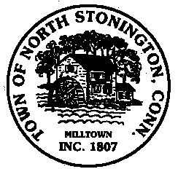 Town of North Stonington
Board of Selectmen Workshop
North Stonington New Town Hall Conference Room
April 17, 2018
5:00 PM

AGENDA

Call to Order
Pledge of Allegiance
Public Comments and Questions

- Ordinances Updates Review
- Annual Town Meeting Preparations
- Staffing Vacancies

Public Comments and Questions
Adjournment

Public Comments limited to 2 minutes on Agenda Items Only

