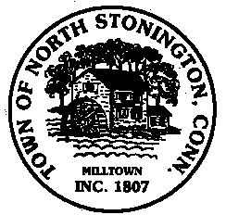 Town of North Stonington
Board of Selectmen Special Meeting
New Town Hall Conference Room
December 1, 2017
2:00 PM

AGENDA

1. Call to Order/ Roll Call
2. Call of and Special Town Meeting for FY 18 Budget and Referendum
3. Discussion of Communication Plan for this and future meetings
4. Adjournment

