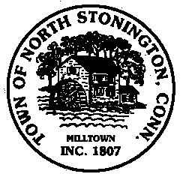 Town of North Stonington
Board of Selectmen Special Meeting
Wheeler Media Center
December 18, 2017
8:15 PM

AGENDA

1. Call to Order/ Roll Call
2. Review of Referendum Results
3. Discussion and Possible Setting of FY 17/18 Mil Rate
4. Appoint Carl Johnson to the Water Pollution Control Authority
5. Adjournment

