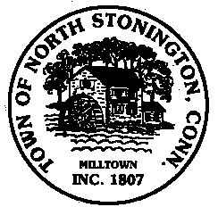 Town of North Stonington
Board of Selectmen Board of Finance Board of Education
Special Meeting
North Stonington New Town Hall Conference Room
March 28, 2018
7:00 PM
AGENDA
Call to Order of Joint Meeting
- Board of Education FY 18-19 Budget Presentation
- Board of Selectmen FY 18-19 Budget Presentation
- De-obligation of Capital Projects Review/Action
- Debt Redemption Schedule
- Annual Meeting Preparation
- Profit and Loss Report Reviews
General Government
Capital Projects and Capital Non-Recurring
Center for Emergency Services
Public Comments and Questions
Adjournment

Public Comments limited to 2 minutes on Agenda Items Only

