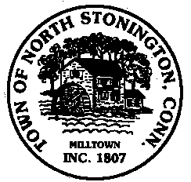
Town of North Stonington
Board of Selectmen
Special Meeting
North Stonington Center for Emergency Services Conference Room
25 Rocky Hollow Road
July 10, 2018
5:30 PM

The North Stonington Board of Selectmen will be hosting a Meet and Greet with the Eastern Pequot Tribal Leadership

